Assessment-5
Experiment 16:
AIM
Implementation of three address codes for a simple program using LEX and YACC tools.

ALGORITHM

1. Initialize temp_count = 0, instr_num = 1
2. FUNCTION new_temp():
Create temp variable t = "t" + temp_count
Increment temp_count
RETURN t
3. FUNCTION print_tac(result, arg1, op, arg2):
IF op is empty
PRINT result = arg1
ELSE
PRINT result = arg1 op arg2
Increment instr_num
4. Read input statement
5. Perform lexical analysis:
Identify NUM, ID, operators, symbols
6. Parse input using grammar rules
7. IF expression contains operator (+, -, *, /):
t = new_temp()
print_tac(t, operand1, operator, operand2)
RETURN t
8. IF assignment statement (ID = expr):
print_tac(ID, expr_result, "", "")
9. Repeat steps for all statements
10. Print total instructions and temporaries

SOURCE CODE

tac.l
%{
#include "tac.tab.h"
#include <string.h>
%}

%%

[0-9]+ { yylval.ival = atoi(yytext); return NUM; }
[a-zA-Z][a-zA-Z0-9_]* { strncpy(yylval.sval, yytext, 63); return ID; }
"+" { return PLUS; }
"-" { return MINUS; }
"*" { return MUL; }
"/" { return DIV; }
"=" { return ASSIGN; }
"(" { return LPAREN; }
")" { return RPAREN; }
";" { return SEMI; }
[ \t\n] { /* skip whitespace */ }
. { fprintf(stderr, "Unknown char: %s\n", yytext); }

%%

int yywrap() { return 1; }

tac.y
%{
#include <stdio.h>
#include <stdlib.h>
#include <string.h>

int temp_count = 0;
int instr_num = 1;

char* new_temp() {
char* t = (char*)malloc(16);
sprintf(t, "t%d", temp_count++);
return t;
}

void print_tac(const char* result, const char* arg1, const char* op, const char* arg2) {
if (op == NULL || strlen(op) == 0)
printf(" [%2d] %-6s = %-6s\n", instr_num++, result, arg1);
else
printf(" [%2d] %-6s = %-6s %s %s\n", instr_num++, result, arg1, op, arg2);
}

void yyerror(const char* s) {
fprintf(stderr, "\n ERROR: %s\n", s);
fprintf(stderr, " Tip: End every statement with semicolon ';'\n");
fprintf(stderr, " Example: a = b + c * d;\n\n");
}

int yylex();
%}

%union {
int ival;
char sval[64];
}

%token <ival> NUM
%token <sval> ID
%token PLUS MINUS MUL DIV ASSIGN LPAREN RPAREN SEMI

%type <sval> expr term factor

%%

program
: stmtlist
;

stmtlist
: stmtlist stmt
| stmt
;

stmt
: ID ASSIGN expr SEMI {
print_tac($1, $3, "", "");
printf("\n");
}
;

expr
: expr PLUS term {
char* t = new_temp();
print_tac(t, $1, "+", $3);
strncpy($$, t, 63);
free(t);
}
| expr MINUS term {
char* t = new_temp();
print_tac(t, $1, "-", $3);
strncpy($$, t, 63);
free(t);
}
| term {
strncpy($$, $1, 63);
}
;

term
: term MUL factor {
char* t = new_temp();
print_tac(t, $1, "*", $3);
strncpy($$, t, 63);
free(t);
}
| term DIV factor {
char* t = new_temp();
print_tac(t, $1, "/", $3);
strncpy($$, t, 63);
free(t);
}
| factor {
strncpy($$, $1, 63);
}
;

factor
: LPAREN expr RPAREN {
strncpy($$, $2, 63);
}
| NUM {
sprintf($$, "%d", $1);
}
| ID {
strncpy($$, $1, 63);
}
;

%%

int main() {
printf("\n");
printf(" ╔══════════════════════════════════════════════╗\n");
printf(" ║ Three Address Code Generator ║\n");
printf(" ║ Using LEX (Flex) + YACC (Bison) ║\n");
printf(" ╚══════════════════════════════════════════════╝\n\n");
printf(" HOW TO USE:\n");
printf(" Type a statement like: a = b + c * d;\n");
printf(" IMPORTANT: end with semicolon -> ;\n");
printf(" Press Ctrl+D when done.\n\n");
printf(" ┌──────────────────────────────────────────────┐\n");
printf(" │ Generated TAC Output │\n");
printf(" └──────────────────────────────────────────────┘\n\n");

yyparse();

printf(" ══════════════════════════════════════════════\n");
printf(" Total instructions : %d\n", instr_num - 1);
printf(" Temporaries used : t0 to t%d (%d total)\n",
temp_count > 0 ? temp_count-1 : 0, temp_count);
printf(" ══════════════════════════════════════════════\n\n");
return 0;
}

OUTPUT

bison -d tac.y && flex tac.l && gcc tac.tab.c lex.yy.c -o tac_lex_yacc
./tac_lex_yacc

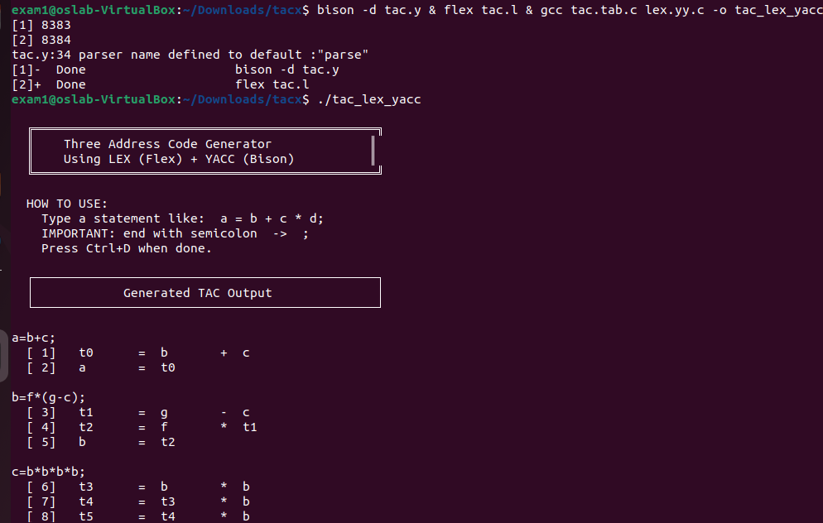

Experiment 17:
AIM
Implement simple code optimization techniques (Constant folding, Strength reduction and Algebraic transformation)

ALGORTHIM
Step 1 Start the program.
Step 2 Initialize counters:
cnt_cf = 0 (Constant Folding)
cnt_sr = 0 (Strength Reduction)
cnt_at = 0 (Algebraic Transformation)
Step 3 Read the number of input statements n.
Step 4 For each statement:
Read input expression (e.g., a = b * 1)
Step 5 Trim the input:Remove spaces, newline, and semicolon.
Step 6 Parse the expression:
Split into:
result (LHS)
arg1, arg2 (operands)
operator (+, -, *, /, %)
Check whether operands are constants.
Step 7 Apply Algebraic Transformation:
If x + 0 → x
If x * 1 → x
Replace expression accordingly
Increment cnt_at
Step 8 Apply Constant Folding:
If both operands are constants:
Compute result (e.g., 2 + 3 = 5)
Replace expression with computed value
Increment cnt_cf
Step 9 Apply Strength Reduction:
If multiplication with small constant:
Replace x * 3 → x + x + x
Increment cnt_sr
Step 10 Print:
Original expression
Optimized expression
Technique used
After all inputs: Print summary counts

CODE

#include <stdio.h>
#include <stdlib.h>
#include <string.h>
#include <ctype.h>

/* -- Types -- */
typedef enum { OP_ADD, OP_SUB, OP_MUL, OP_DIV, OP_MOD, OP_NONE } OpType;

typedef struct {
char result[64];
char arg1[64];
char arg2[64];
OpType op;
int is_const1;
int is_const2;
double val1;
double val2;
} Expr;

typedef struct {
char original[256];
char optimized[256];
char technique[64];
int changed;
} OptResult;

/* Counters */
int cnt_cf = 0, cnt_sr = 0, cnt_at = 0;

/* -------- Helpers -------- */

int is_number(const char* s, double* val) {
char* end;
if (!s || s[0] == '\0') return 0;
*val = strtod(s, &end);
return (end != s && (*end == '\0' || *end == ';'));
}

OpType char_to_op(char c) {
if (c == '+') return OP_ADD;
if (c == '-') return OP_SUB;
if (c == '*') return OP_MUL;
if (c == '/') return OP_DIV;
if (c == '%') return OP_MOD;
return OP_NONE;
}

void trim(char* s) {
int i, len;
i = 0;
while (s[i] == ' ' || s[i] == '\t' || s[i] == '\r') i++;
memmove(s, s + i, strlen(s) - i + 1);
len = strlen(s);
while (len > 0 && (s[len-1] == ' ' || s[len-1] == '\n' || s[len-1] == '\t' || s[len-1] == '\r' || s[len-1] == ';'))
s[--len] = '\0';
}

/* -------- Parser -------- */

int parse_expr(const char* line, Expr* e) {
char buf[256];
char *eq, *rhs, *op_pos;
int i;

op_pos = NULL;
strncpy(buf, line, 255);
buf[255] = '\0';
trim(buf);

eq = strchr(buf, '=');
if (!eq) return 0;

*eq = '\0';
strcpy(e->result, buf);
trim(e->result);

rhs = eq + 1;
trim(rhs);

for (i = 0; rhs[i] != '\0'; i++) {
if (i > 0 && (rhs[i] == '+' || rhs[i] == '-' || rhs[i] == '*' || rhs[i] == '/' || rhs[i] == '%')) {
op_pos = &rhs[i];
e->op = char_to_op(rhs[i]);
break;
}
}

if (op_pos == NULL) {
strcpy(e->arg1, rhs);
e->arg2[0] = '\0';
e->op = OP_NONE;
} else {
*op_pos = '\0';
strcpy(e->arg1, rhs);
strcpy(e->arg2, op_pos + 1);
trim(e->arg1);
trim(e->arg2);
}

e->is_const1 = is_number(e->arg1, &e->val1);
e->is_const2 = is_number(e->arg2, &e->val2);

return 1;
}

/* -------- Optimizations -------- */

int try_constant_fold(Expr* e, OptResult* r) {
double res;
if (!e->is_const1 || !e->is_const2 || e->op == OP_NONE) return 0;

if (e->op == OP_ADD) res = e->val1 + e->val2;
else if (e->op == OP_SUB) res = e->val1 - e->val2;
else if (e->op == OP_MUL) res = e->val1 * e->val2;
else if (e->op == OP_DIV && e->val2 != 0) res = e->val1 / e->val2;
else return 0;

sprintf(r->optimized, "%s = %.0f;", e->result, res);
strcpy(r->technique, "Constant Folding");
r->changed = 1;
cnt_cf++;
return 1;
}

int try_algebraic(Expr* e, OptResult* r) {
if (e->op == OP_ADD) {
if (e->is_const2 && e->val2 == 0) {
sprintf(r->optimized, "%s = %s;", e->result, e->arg1);
goto match;
}
if (e->is_const1 && e->val1 == 0) {
sprintf(r->optimized, "%s = %s;", e->result, e->arg2);
goto match;
}
}
if (e->op == OP_MUL) {
if (e->is_const2 && e->val2 == 1) {
sprintf(r->optimized, "%s = %s;", e->result, e->arg1);
goto match;
}
if (e->is_const1 && e->val1 == 1) {
sprintf(r->optimized, "%s = %s;", e->result, e->arg2);
goto match;
}
}
return 0;

match:
strcpy(r->technique, "Algebraic");
r->changed = 1;
cnt_at++;
return 1;
}

int try_strength(Expr* e, OptResult* r) {
double multiplier;
char variable[64];
char buffer[256];
int found, m, k;

multiplier = 0;
found = 0;
variable[0] = '\0';
buffer[0] = '\0';

if (e->op == OP_MUL) {
if (e->is_const1 && !e->is_const2) {
multiplier = e->val1;
strcpy(variable, e->arg2);
found = 1;
} else if (e->is_const2 && !e->is_const1) {
multiplier = e->val2;
strcpy(variable, e->arg1);
found = 1;
}

if (found && multiplier > 1 && multiplier <= 10 && multiplier == (int)multiplier) {
m = (int)multiplier;
strcpy(buffer, variable);
for (k = 1; k < m; k++) {
strcat(buffer, " + ");
strcat(buffer, variable);
}
sprintf(r->optimized, "%s = %s;", e->result, buffer);
strcpy(r->technique, "Strength Reduction");
r->changed = 1;
cnt_sr++;
return 1;
}
}
return 0;
}

OptResult optimize(const char* line) {
OptResult r;
Expr e;

strcpy(r.original, line);
trim(r.original);
strcat(r.original, ";");

strcpy(r.optimized, r.original);
strcpy(r.technique, "None");
r.changed = 0;

if (!parse_expr(line, &e)) return r;

if (try_algebraic(&e, &r)) return r;
if (try_constant_fold(&e, &r)) return r;
if (try_strength(&e, &r)) return r;

return r;
}

/* -------- MAIN -------- */

int main() {
int n, j;
char input[256];
OptResult r;

printf("Enter number of statements: ");
if (scanf("%d", &n) != 1) return 1;
getchar();

for (j = 0; j < n; j++) {
printf("\nEnter statement %d: ", j + 1);
if (!fgets(input, sizeof(input), stdin)) break;

r = optimize(input);

printf("Original: %s\n", r.original);
printf("Optimized: %s\n", r.optimized);
printf("Technique: %s\n", r.technique);
}

printf("\n--- Summary ---\n");
printf("Constant Folding: %d\n", cnt_cf);
printf("Algebraic: %d\n", cnt_at);
printf("Strength Reduc: %d\n", cnt_sr);

return 0;
}

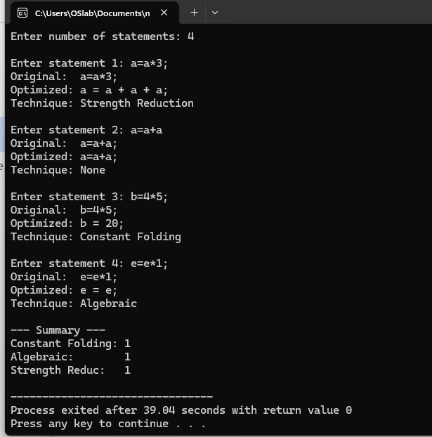

Experiment 18:
AIM
Implement Back-End of the compiler for which three address code is given as input and the 8086 assembly language is produced as output.

ALGORITHM

Step 1 Start the program ,Initialize empty tables:
TAC statements array
Symbol table
Output file for assembly (output.asm)
Step 2 Input TAC statements
Prompt the user to enter TAC statements (result = arg1 op arg2)
Stop when user types "done"
Step 3 Trim and parse each line
Remove leading/trailing spaces
Split the statement into:
result (left-hand side)
arg1 (first operand)
arg2 (second operand, if binary)
op (operator, if binary)
Step 4 Add symbols to symbol table ,Add all identifiers (result, arg1, arg2) to symbol table if they are not numeric
Step 5 Open assembly output file
Write headers for 8086 assembly:
.MODEL SMALL
.STACK
.DATA section with all symbols
.CODE section with MAIN PROC and DS initialization
Step 6 Generate assembly for each TAC
For each TAC:
If unary (no operator):
Load arg1 into AX
Store AX into result
If binary (+, -, *, /):
Load arg1 into AX
Load arg2 into BX if needed (or use immediate if numeric)
Perform operation (ADD, SUB, MUL, DIV)
Store AX into result
Step 7 Handle numeric constants
If an operand is a number, use immediate value in instructions
Else, use memory reference [var]
Step 8 Emit assembly
Print to console and write to file
Include comments showing original TAC for readability
Step 9 Terminate program,Add standard 8086 exit instructions:
MOV AX, 4C00H
INT 21H
Step 10 Close file and end
Write END MAIN in assembly
Close output.asm file
Exit program

SOURCE CODE
#include <stdio.h>
#include <stdlib.h>
#include <string.h>
#include <ctype.h>
#include <stdarg.h>

#define MAX_VARS 64
#define MAX_INSTRS 128

typedef struct {
char result[32];
char arg1[32];
char op[4];
char arg2[32];
int is_binary;
} TAC;

static TAC tac[MAX_INSTRS];
static int tac_count = 0;
static char sym[MAX_VARS][32];
static int sym_count = 0;
static FILE* out;

void emit(const char* fmt, ...) {
va_list ap;
char buf[256];
va_start(ap, fmt);
vsnprintf(buf, 255, fmt, ap);
va_end(ap);
printf("%s\n", buf);
fprintf(out, "%s\n", buf);
}

void trim(char* s) {
int i = 0;
while (s[i]==' '||s[i]=='\t') i++;
memmove(s, s+i, strlen(s)-i+1);
int len = strlen(s);
while (len>0 && (s[len-1]==' '||s[len-1]=='\t'||s[len-1]=='\n'||s[len-1]=='\r'))
s[--len] = '\0';
}

int is_num(const char* s) {
if (!s||!*s) return 0;
int i = (*s=='-') ? 1 : 0;
for (; s[i]; i++) if (!isdigit(s[i])) return 0;
return 1;
}

void add_sym(const char* name) {
if (is_num(name)) return;
for (int i=0; i<sym_count; i++)
if (strcmp(sym[i], name)==0) return;
strcpy(sym[sym_count++], name);
}

int parse_line(const char* line, TAC* t) {
char buf[256];
strncpy(buf, line, 255);
trim(buf);
if (!buf[0] || buf[0]==';') return 0;

char* eq = strchr(buf, '=');
if (!eq) return 0;
*eq = '\0';
strncpy(t->result, buf, 31); trim(t->result);

char rhs[128];
strncpy(rhs, eq+1, 127); trim(rhs);

char* op_pos = NULL;
char op_ch = 0;
for (int i=1; rhs[i]; i++) {
if (rhs[i]=='+'||rhs[i]=='-'||rhs[i]=='*'||rhs[i]=='/') {
op_pos = &rhs[i];
op_ch = rhs[i];
break;
}
}

if (op_pos) {
*op_pos = '\0';
strncpy(t->arg1, rhs, 31); trim(t->arg1);
strncpy(t->arg2, op_pos+1, 31); trim(t->arg2);
t->op[0] = op_ch; t->op[1] = '\0';
t->is_binary = 1;
} else {
strncpy(t->arg1, rhs, 31); trim(t->arg1);
t->arg2[0] = '\0';
t->op[0] = '\0';
t->is_binary = 0;
}
return 1;
}

void load(const char* reg, const char* v) {
if (is_num(v)) emit(" MOV %s, %s", reg, v);
else emit(" MOV %s, [%s]", reg, v);
}

void gen(TAC* t) {
emit("; %s = %s %s %s",
t->result, t->arg1,
t->is_binary ? t->op : "",
t->is_binary ? t->arg2 : "");

if (!t->is_binary) {
load("AX", t->arg1);
emit(" MOV [%s], AX", t->result);

} else if (t->op[0] == '+') {
load("AX", t->arg1);
is_num(t->arg2) ? emit(" ADD AX, %s", t->arg2)
: emit(" ADD AX, [%s]", t->arg2);
emit(" MOV [%s], AX", t->result);

} else if (t->op[0] == '-') {
load("AX", t->arg1);
is_num(t->arg2) ? emit(" SUB AX, %s", t->arg2)
: emit(" SUB AX, [%s]", t->arg2);
emit(" MOV [%s], AX", t->result);

} else if (t->op[0] == '*') {
load("AX", t->arg1);
is_num(t->arg2) ? emit(" MOV BX, %s", t->arg2)
: emit(" MOV BX, [%s]", t->arg2);
emit(" MUL BX");
emit(" MOV [%s], AX", t->result);

} else if (t->op[0] == '/') {
load("AX", t->arg1);
emit(" XOR DX, DX");
is_num(t->arg2) ? emit(" MOV BX, %s", t->arg2)
: emit(" MOV BX, [%s]", t->arg2);
emit(" DIV BX");
emit(" MOV [%s], AX", t->result);
}
emit("");
}

int main() {
out = fopen("output.asm", "w");

printf("Enter TAC statements. Type 'done' when finished.\n");
printf("Format : result = arg1 op arg2\n");
printf("Example: t0 = b * c\n\n");

char line[256];
while (tac_count < MAX_INSTRS) {
printf(">> ");
fflush(stdout);
if (!fgets(line, sizeof(line), stdin)) break;
trim(line);
if (strcmp(line, "done") == 0) break;
if (!line[0]) continue;
TAC t;
memset(&t, 0, sizeof(t));
if (parse_line(line, &t))
tac[tac_count++] = t;
else
printf(" [skip] could not parse: %s\n", line);
}

/* Collect symbols */
for (int i=0; i<tac_count; i++) {
add_sym(tac[i].result);
add_sym(tac[i].arg1);
if (tac[i].is_binary) add_sym(tac[i].arg2);
}

printf("\n========== 8086 Assembly ==========\n\n");
fprintf(out, "; 8086 Assembly - Generated by Compiler Back-End\n\n");

emit(".MODEL SMALL");
emit(".STACK 100H");
emit("");
emit(".DATA");
for (int i=0; i<sym_count; i++)
emit(" %-10s DW 0", sym[i]);
emit("");
emit(".CODE");
emit("MAIN PROC");
emit(" MOV AX, @DATA");
emit(" MOV DS, AX");
emit("");

for (int i=0; i<tac_count; i++)
gen(&tac[i]);

emit(" MOV AX, 4C00H");
emit(" INT 21H");
emit("MAIN ENDP");
emit("END MAIN");

fclose(out);
printf("\nSaved to: output.asm\n");
return 0;
}

OUTPUT
